

Independent Service Providers

# Claresholm & Area Support Services

**MISSION:**To empower the people of Claresholm and District to attain a desirable quality of life.

**VISION:**Claresholm and District FCSS envision a strong, healthy, positive and caring community which maintains a high quality of life through mutual respect and interaction.

person sitting on books working on laptop computer

Claresholm & District FCSS

4925 1st Street West

PO Box 1297

Claresholm AB T0L 0T0

Phone: (403) 625-4417

Fax: (403) 625-4851

[www.claresholmfcss.ca](http://www.claresholmfcss.ca)

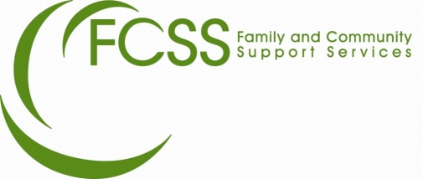

HOUSEKEEPING

**Sonja Poot**

403-795-8128

**Melissa Manshanden Chiasson**

403-869-1824

**April Lungal**

403-489-0434

**Domestic Goddess Cleaning**

403-489-0249

**Clean to a ‘T’**

403-549-2525

WELLNESS

**Universoul- Cindy Hubka B.N**

Clinical Hypnotherapist

Reiki, NLP, EFT, META Healthcoach

403-625-6314

[cindy.hubka@gmail.com](mailto:cindy.hubka@gmail.com)

**Jade’s Alchemy Connection- Jade Soetart**

Facilitator

Meditation, LaughterYoga, Spiritual Mediumship, Heart Virtues

403-625-1600

<truelife@xplornet.com>

### Foot Care

**SC Foot Care- Sonja Caswell**

403-687-3021

403-682-9751

**Tasha’s Travelling Toes-**

**Natasha McAuley**

Certified Advanced Foot Care Specialist

403-489-0543

**Darlene Wolff, LPN**

403-682-9176

[buddy59@shaw.ca](mailto:buddy59@shaw.ca)

**HOUSEKEEPING**

**Ashtine Cleaning Services-**

**Genalin Mandac**

Residential and Commercial

403-682-9058

[genalinmandac@yahoo.com](mailto:genalinmandac@yahoo.com)

**Bonnie Williamson**

**Housekeeping Services**

403-468-4000

**Linda**

403-585-7447

403-625-4277

YARD CARE

**Mowers and Blowers**

Darren Sanders

403-625-0301

**K & R**

Colt Trotter

403-359-0406

**Ty Gaddye- Lawn Mowing**

403-625-3510

**Jeremiah’s Snow Removal & Yardworks**

403-625-0759

MISCELLANEOUS

**Odd Jobs and Random Tasks**

Gaven Moore

403-625-3452

For information on open positions or to submit your resume, please visit our Web site at: www.lucernepublishing.com